REPUBLIC OF CAMEROON
Peace - Work - Fatherland MINISTRY OF HIGHER EDUCATION REGIONAL DELEGATION OF CENTER
PKFokam Institute of Excellence
Dignity - Faith - Responsibility
P.O. Box 11646 Yaounde - Cameroon
REPUBLIC OF CAMEROON
Paix- Travail- Patrie

MINISTERE DE L'ENSEIGNEMENT
SUPERIEUR
DELEGATION REGIONALE DU CENTRE
PKFokam Institute of Excellence
Dignite - Foi – Responsabilite
B.P. 11646 Yaounde - Cameroun

Progressive Report

Project: Wedding Invitation and Gift Management System (WIGMS)

GROUP 3
NAME | MATRICULE | PERCENTAGE PARTICIPATION
TCHOUNGA NGATCHOU MARIE CLAIRE | 26S022 | 25%
MASSADO DJOKO AICHA CLAUDIA | 26S033 | 25%
NKOMPNANG GUILLAUME JUNIOR | 26S017 | 25%
AVOUTIA DONGMO BRAYANN | 26S028 | 25%

SUPERVISOR: MR MBIETIEU AMOS
Academic Year: 2025/2026

Table of Contents

- Introduction ……………………………………………………………………….2

- Objectives of the Module ………………………………………………………..2

- Work Distribution …………………………………………………………………3

- Structure of a Person ……………………………………………………………3

- Implemented Functions ………………………………………………………….4

- Setting Up a GitHub Repository ………………………………………………...5

- Tools And Technologies Used………………………………………………….7

- Difficulties Encountered and Proposed Solutions…………………………….8

- Next Steps of the Project ………………………………………………………..9

- Conclusion ………………………………………………………………………..9

Introduction
The aim of this project is to design and implement a software system that can assist in organizing wedding invitations and managing the gifts received during the ceremony. The system will be developed using the C programming language following a modular architecture. This approach allows the program to be divided into independent modules that can be developed, tested, and maintained more easily.
This first report focuses on Module 1: Person Management for the Wedding Invitation and Gift Management System developed using the C programming language. This module is responsible for managing information related to people involved in the wedding event, particularly guests.
MODULE 1: PERSON MANAGEMENT
VERSION: V1.0

Objectives of the Module
- Define a Person structure to store guest information.
- Implement a function to create a new person.
- Implement a function to display a person's information.
- Implement a function to update a person's information.
- Apply structured programming concepts using C language.

Work Distribution

Group Member | Role | Assigned Tasks
Tchounga Ngatchou Marie Claire | Module Design | Designed Person structure
Avoutia Dongmo Brayann | Function Implementation | Implemented create_person()
Nkompnang Guillaume Junior | Display Function | Implemented display_person()
Massado Djocko Aicha | Update Function | Implemented update_person()

- Person Structure
A Person represents an invited guest. The structure stores basic information such as ID, name, age and phone number.
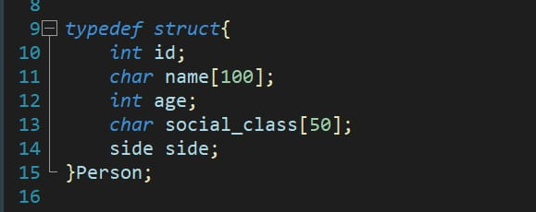

Implemented Functions

create_person ()

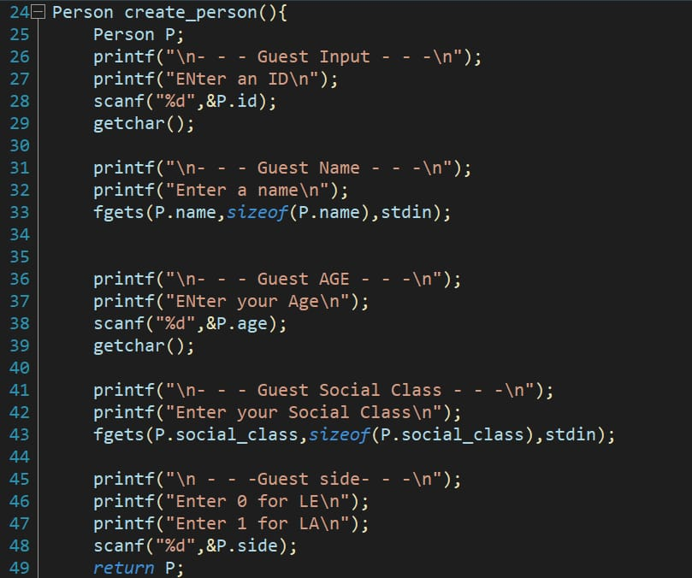

display_person ()

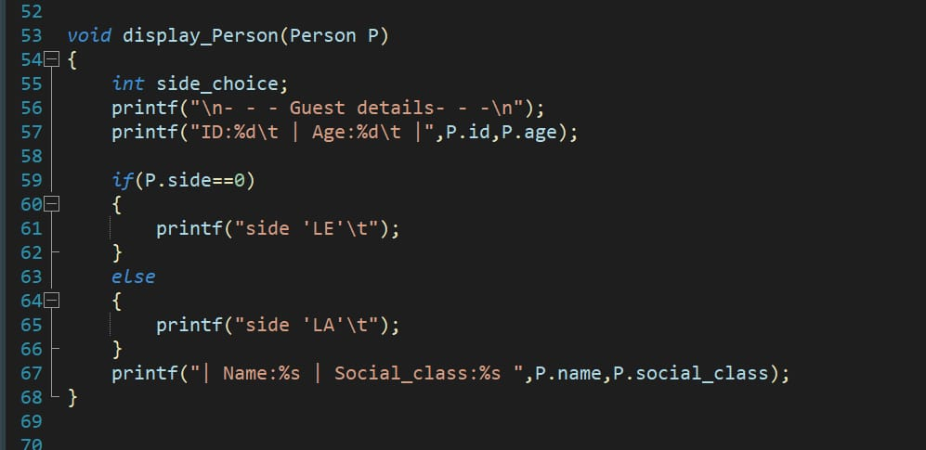

Setting Up a GitHub Repository
To create a GitHub repository using the web interface, follow these steps:

Step 1: Creating the GitHub accounts
To sign up for an account, navigate to https://github.com/ and follow the prompts. To keep your GitHub account secure you should use a strong and unique password.

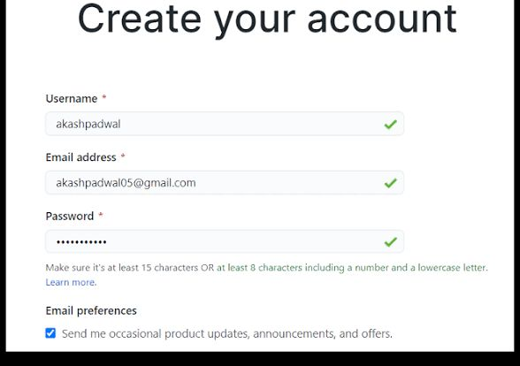

Step 2: Creating the Repository

Here is the GitHub link to access our repository: https://github.com/C-programming-project-1/C- PROGRAMMING-PROJECT-REPOSITORY Start a new repository in the upper-right corner of any page, select the plus (+) icon, then click New repository

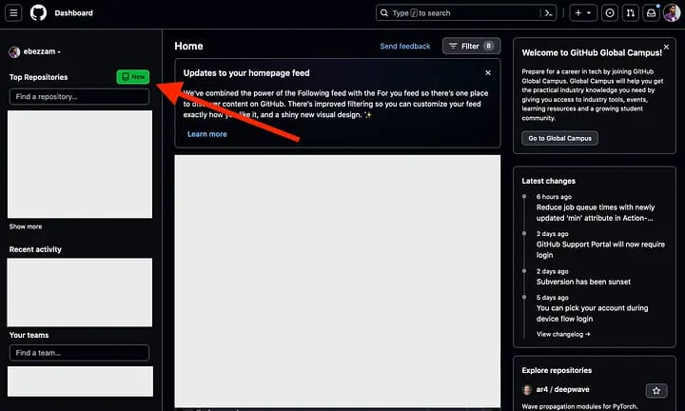

Step 3: Specify an owner
If you belong to any organizations, use the "Owner" dropdown menu to select the account (your personal account or an organization) that will own the repository. Enter a name — type a short, memorable name for your repository in the "Repository name" box.

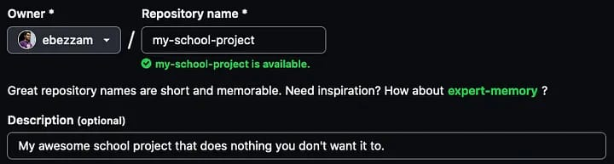

Step 4: Choose repository visibility
Decide whether the repository will be Public (anyone can see it) or Private (only you and collaborators you choose can access it).

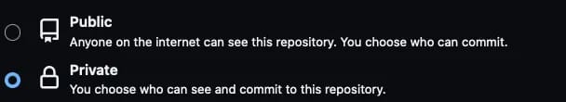

Step 5: Initialize the repository
Select Add a README file to create a document that describes your project. You can also optionally add a .gitignore file (to exclude specific file types from version control) and a license.

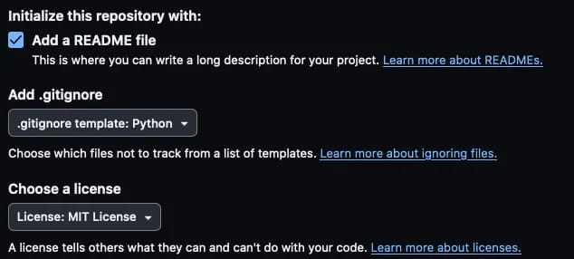

Step 6: Create the repository
Click the green Create repository button at the bottom of the page.

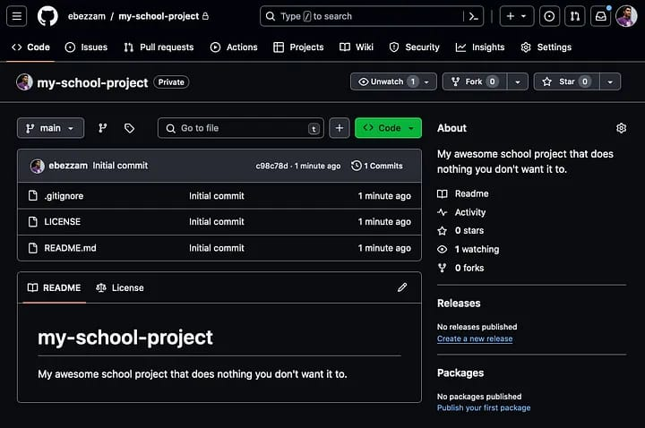

Step 7: Start using your repository
GitHub repository is now created and ready for you to start adding files and managing your project with version control. You can then clone the repository to your local machine using the provided URL to work with it locally.
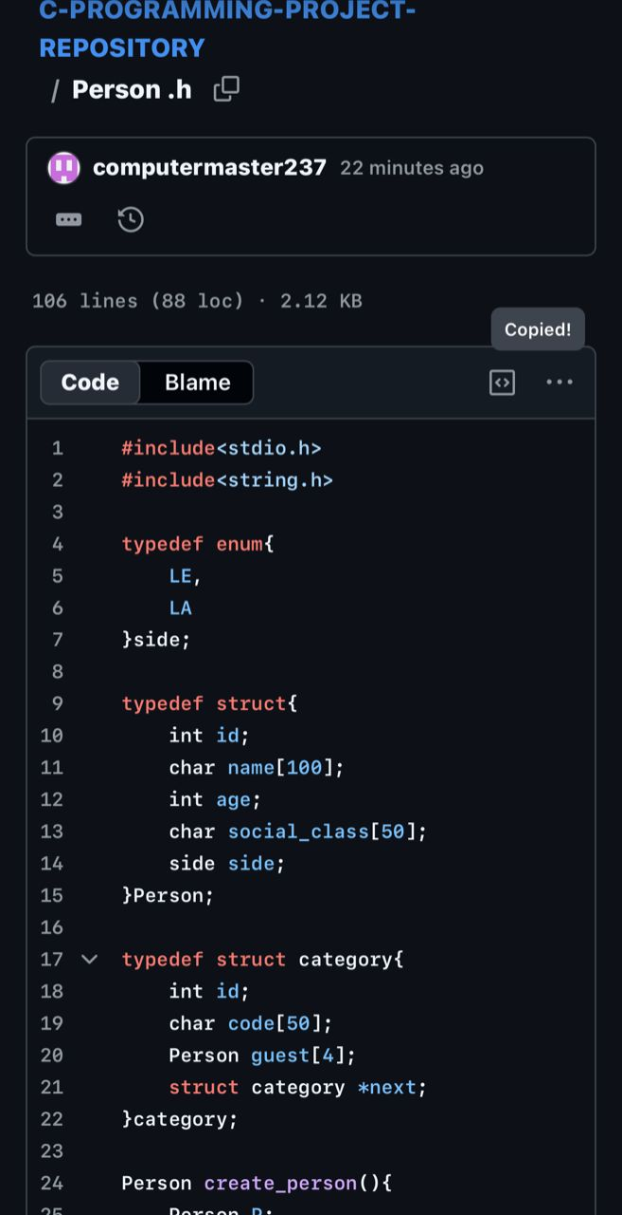

Tools and Technologies Used

- C Programming Language for software development.

- GitHub platform for version control and team collaboration.


- Standard C libraries such as stdio.h and string.h

Difficulties Encountered and Proposed Solutions
During the implementation of Module 1: Person Management, several challenges were encountered by the group. These difficulties were mainly related to understanding some concepts of the C programming language and handling user inputs. The following problems were identified and appropriate solutions were applied.

Difficulty in Understanding Structures in C
One of the first challenges was understanding how to define and use structures in the C programming language. Some members initially had difficulties understanding how different variables such as integers and strings could be grouped into a single structure representing a person.

Proposed Solution:
To overcome this difficulty, the group studied examples of structures from lecture notes and online programming resources. Additional practice programs were written to better understand how structures store and organize data. This helped the team correctly define the Person structure used in the module.

Managing User Input
Another difficulty encountered was handling user input correctly when reading both strings and integers using functions such as scanf(). Some input errors occurred during testing, especially when entering names or phone numbers.

Proposed Solution:
The group carefully reviewed how input functions work in C and corrected the input statements in the program. Additional tests were performed to ensure that the program correctly reads user data without causing errors.

Difficulty in Creating the Repository
Also, we encountered was creating the project repository and properly initializing it. Some members were not familiar with repository management tools such as Git and platforms like GitHub. As a result, there was confusion about how to initialize the repository, upload the project files, and share access with other team members.

Proposed Solution:
To solve these issues, the group took several measures. First, members studied basic tutorials on how to use Git and GitHub for version control. This helped them understand how to create a repository, upload files, and track changes. Secondly, the group designated one member to initially set up the repository and explain the process to other members. This ensured that the repository was properly created and accessible to all team members.

Collaboration and Task Coordination
Since the project was carried out in a group, coordinating tasks among members was initially a challenge. Ensuring that every member clearly understood their responsibilities required proper communication.

Proposed Solution:
The group organized regular discussions to divide tasks clearly among members and monitor the progress of the work. This improved collaboration and ensured that the module was completed efficiently.

Next Steps of the Project
After successfully completing Module 1: Person Management, the next phase of the project will focus on extending the system’s functionality by implementing the remaining modules of the Wedding Ceremony Software.
The immediate next step will be the development of Module 2: Category Management, which will allow the system to organize guests into different categories such as family members, friends, colleagues, and VIP guests. This module will use a linked list data structure to dynamically manage categories and ensure efficient insertion, deletion, and updating of category information.

Conclusion
This module helped the group understand the importance of structures, functions, and pointers in C programming. It also reinforced the concept of modular programming and teamwork during software development.
The Person Management module provides the basic functionality required to manage guest information in the Wedding Invitation and Gift Management System. It allows the creation, display and modification of guest records using structures and pointers in C.

PKFokam Institute of Excellence — C Programming Course — Academic Year 2025/2026

